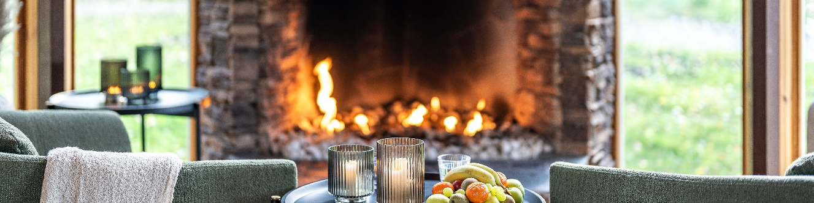

**Reservation for Speedgroup november 23 – 24 2024**

In order to reserve rooms and additional meals please fill in this form and send it to [info@novapark.se](mailto:info@novapark.se)

You will get a confirmation as soon as your reservation is confirmed.   
Contact us at 018 – 34 90 00 or [info@novapark.se](mailto:info@novapark.se) if you have any questions regarding your stay.

**Contact information:**

**Name:**

**Company:**

**Phone number: ______**

**Email: ___ ______**

**Friday november 22nd   
Number of singlerooms ____**

*Price per singleroom/night 1304,80 SEK including breakfast***Number of persons in doubleroom _________**

*Price per person in doubleroom/night 744,80 SEK including breakfast* **Number of persons to dinner** *(main course of the evening)***: _____ ___***Price: 395 SEK* Requested time for dinner reservation (18:00 – 21:00): **_____   
  
  
Saturday november 23rd   
Number of singlerooms _____**

*Price per singleroom/night 1304,80 SEK including breakfast***Number of persons in doubleroom _________**

*Price per person in doubleroom/night 744,80 SEK including breakfast***Number of persons to lunch** *(lunch salad)* **: ___________** *Price: 243, 75 SEK*Requested time for lunch reservation (11:30 – 13:00) : **________________________**

**Room allocation per single- & doublerooms with name of the guests:** *_____*  *______* *_____* *_ ____* *_____* *_____*  *_____* *If you have children with you please state their age above*

**Payment wirh card on site  
Cardnumber, expiry date and CVC-code :**

**All rooms and meals are paid with the same card.**

**The payment should be split on different cards/guests.***Please specify the division below:*

|  |  |  |
| --- | --- | --- |
| **Terms and Conditions**  Cancellation within 4 weeks of arrival is charged at full cost for the total of all rooms and all meals reserved. Last day for free cancellation is 2024-10-26. **Water Lounge is accessible from 18 years and above**.   **Payment**  Payment with card on site. Leave card information (card number, expiry date, CVC) to guarantee your reservation. It is possible to call us and leave card information: 018 – 34 90 00.  *All prices are shown including VAT. |  | **Force Majeure**  Strike, lockout, fire, explosion, war or warlike conditions, substantial restrictions on supplies or other circumstances beyond Nova Park's control entitle Nova Park to terminate the contract without any obligation to pay damages.  To reserve your room with the price for Speedgroup: Send the completed form to info@novapark.se |

**I agree with the terms and conditions**

**Date: Name:**